**TUGAS PRAKTIKUM KONSEP PEMPROGRAMAN**

**JILID 12 part 3**



**Oleh :**

**Nama : Rosi Arif Mulyadi**

**NRP : 3121522021**

**Prodi : D3 Teknik Informatika PENS PSDKU Sumenep**

**Kelas : 1 ITA D3 Sumenep**

**Dosen :**

**Lusiana Agustien M.Kom**

**POLITEKNIK ELEKTRONIKA NEGERI SURABAYA**

**Praktikum 8 (3/4)**

**POINTER**

Untuk setiap program di bawah ini, – gambarkan ilustrasi alokasi memori dari setiap baris pernyataan yang diproses – perkirakan hasil eksekusinya

1. Array of Pointer to char

#include <stdio.h>

#include <stdlib.h>

main()

{

static char *days[] = {"Sun", "Mon", "Tues", "Wed","Thu", "Fri", "Sat"};

int i;

for( i = 0; i < 6; ++i )

printf( "%s\n", days[i]);

}

Jawab :

|  |  |  |
| --- | --- | --- |
| Konstanta | Address | Value |
|  | 1000 | S |
|  |  | u |
|  |  | n |
|  |  | \0 |
|  | 1001 | M |
|  |  | o |
|  |  | n |
|  |  | \0 |
|  | 1002 | T |
|  |  | u |
|  |  | e |
|  |  | s |
|  |  | \0 |
|  | 1003 | W |
|  |  | e |
|  |  | d |
|  |  | \0 |
|  | 1004 | T |
|  |  | h |
|  |  | u |
|  |  | \0 |
|  | 1005 | F |
|  |  | r |
|  |  | i |
|  |  | \0 |
| Variabel | Address | Value |
| days | 2000 | 1000 |
|  |  | 1001 |
|  |  | 1002 |
|  |  | 1003 |
|  |  | 1004 |
|  |  | 1005 |

Output :

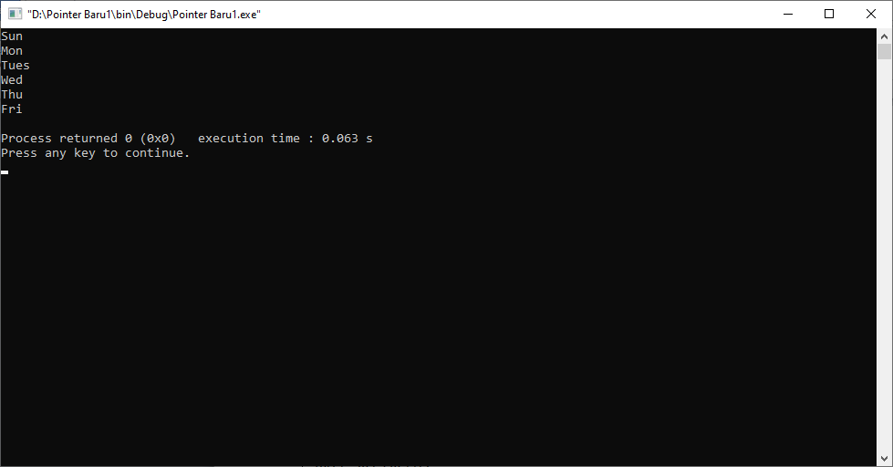

2. Pointer yang menunjuk ke pointer yang lain.

#include <stdio.h>

#include <stdlib.h>

main()

{

int a, *b, **c;

a = 155;

b = &a;

c = &b;

printf("Nilai a = %d atau %d atau %d\n", a, *b, **c);

printf("b = %p = alamat a di memori\n", b);

printf("c = %p = alamat b di memori\n", c);

printf("alamat c di memori = %p\n", &c);

}

Jawab :

|  |  |  |
| --- | --- | --- |
| Variabel | Address | Value |
| a | 0060FEFC | 155 |
| b | 0060FEF8 | 0060FEFC |
| c | 0060FEF4 | 0060FEF8 |

Output :

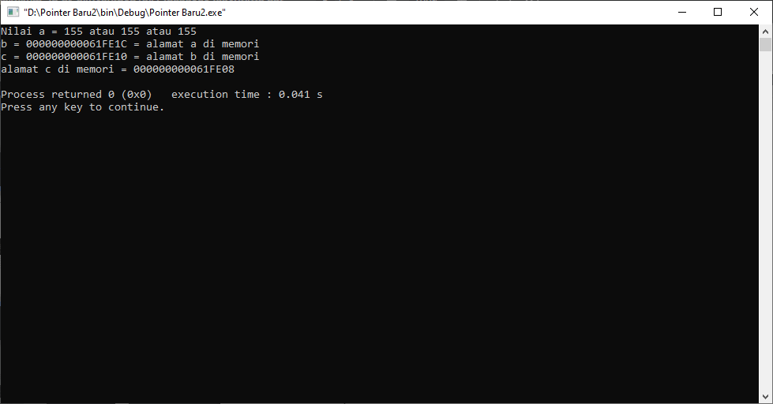

3. Pointer yang menunjuk ke pointer yang lain.

#include <stdio.h>

#include <stdlib.h>

main()

{

int var_x = 273;

int *ptr1;

int **ptr2;

ptr1 = &var_x;

ptr2 = &ptr1;

printf("Nilai var_x = *ptr1 = %d\n", *ptr1);

printf("Nilai var_x = **ptr2 = %d\n\n", **ptr2);

printf("ptr1 = &var_x = %p\n", ptr1);

printf("ptr2 = &ptr1 = %p\n", ptr2);

printf(" &ptr2 = %p\n", &ptr2);

}

Jawab :

|  |  |  |
| --- | --- | --- |
| Variabel | Address | Value |
| Var_X | 0060FEFC | 273 |
| ptr1 | 0060FEF8 | 0060FEFC |
| ptr2 | 0060FEF4 | 0060FEF8 |

Output :

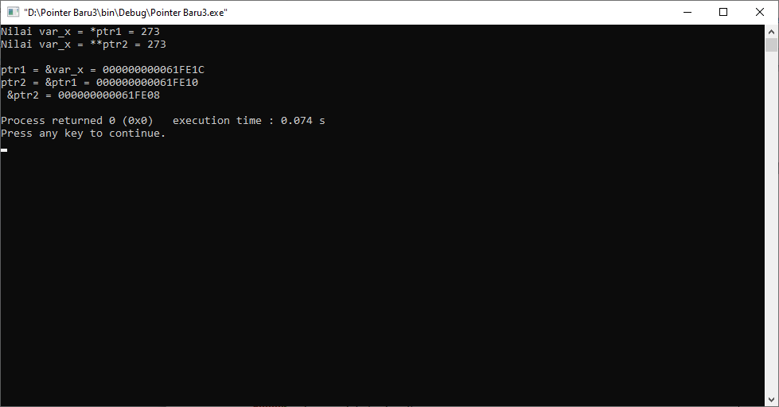

4. #include <stdio.h>

#include <stdlib.h>

main()

{

int a, *b, **c;

a = 1975;

b = &a;

c = &b;

printf("Nilai a = %d atau %d atau %d\n", a, *b, **c);

printf("b = %p = alamat a di memori\n", b);

printf("c = %p = alamat b di memori\n", c);

printf("alamat c di memori = %p\n", &c);

}

Jawab :

|  |  |  |
| --- | --- | --- |
| Variabel | Address | Value |
| a | 0060FEFC | 1975 |
| b | 0060FEF8 | 0060FEFC |
| c | 0060FEF4 | 0060FEF8 |

Output :

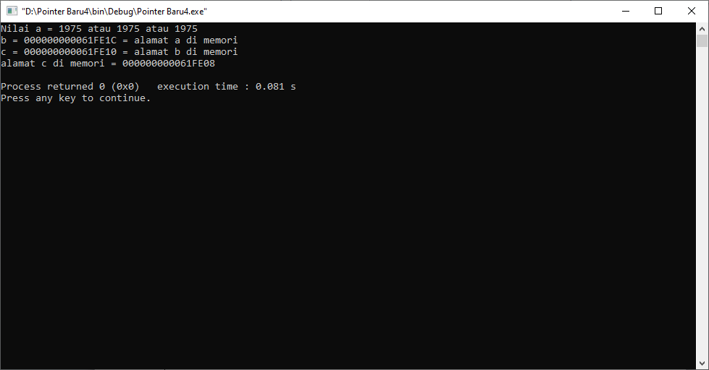

5. Untuk potongan program di bawah ini, gambarkan ilustrasi alokasi memori dari setiap baris pernyataan yang diproses

int *i;

int j=10, k, m[]={2, 5};

int **l;

i = m;

i++;

*i = j;

j = *i;

i = &j;

k = *(&j);

l = &i;

Jawab :

|  |  |  |
| --- | --- | --- |
| Variabel | Address | Value |
| m[0] | 0060FEEC | 2 |
| m[1] | 0060FEF0 | 5 10 |
| i | 0060FEFC | 0060FEEC 0060FEF0 0060FEF8 |
| j | 0060FEF8 | 10 10 |
| k | 0060FEF4 | 10 |
| l | 0060FEE8 | 0060FEFC |

6. Tentukan setiap statemen di bawah ini benar atau salah. Jika salah sertakan alasannya. Deklarasi :

int a[5] = {2,4,8,1,23};

int c = 5;

int *ptr1 = &c;

int *ptr2 = a;

|  |  |  |
| --- | --- | --- |
| Statement | Benar (beri tanda X) | Salah (beri tanda X) |
| a = c; |  |  |
| *c = 6; |  |  |
| a[2] = c; |  |  |
| *ptr2 = c; |  |  |
| &ptr1 = c; |  |  |
| *(ptr2 + 1) = *(a + 3); |  |  |
| c = *(ptr2 + 1); |  |  |
| c = &ptr1; |  |  |
| c = a[3] + 2; |  |  |

Jawab :

|  |  |  |
| --- | --- | --- |
| Variabel | Address | Value |
| a[0] | 0060FEE8 | 2 |
| a[1] | 0060FEEC | 4 |
| a[2] | 0060FEF0 | 8 |
| a[3] | 0060FEF4 | 1 |
| a[4] | 0060FEF8 | 23 |
| C | 0060FEE4 | 5 |
| ptr1 | 0060FEE0 | 0060FEE4 |
| ptr2 | 0060FEDC | 0060FEE8 |

NB : 0060FEE4 = 5

0060FEE8 = 2

|  |  |  |  |
| --- | --- | --- | --- |
| Statement | Benar | Salah | Alasan |
| a=c; |  | X | Karena variabel a adalah array dan c adalah variabel biasa. Value c tidak bisa langsung di assign ke variabel a, variabel a harus ditulis dengan indeksnya |
| *c=6; |  | X | Karena variable c bukan pointer |
| a[2]=c; | X |  |  |
| *ptr=c; | X |  |  |
| &ptr1=c; |  | X | Karena value c tidak dapat diassign menjadi alamat pointer ptr1 |
| *(ptr2+1)=*(a+3); | X |  |  |
| c=*(ptr2+1); | X |  |  |
| c=&ptr1; |  | X | Jika kita mencari value dari c menggunakan %d maka akan terjadi error karena alamat pointer tidak dapat diassign ke variable |
| c=a[3]+2; | X |  |  |
| *(ptr2+2)=*ptr1; | X |  |  |